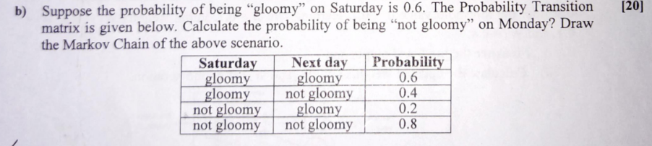

Saturday -> Gloomy =0.6 , NotGloomy = 0.4

p(Sunday = Gloomy) = p (Sunday = Gloomy | Saturday =Gloomy) \* p (Saturday = Gloomy) +

p(Sunday = Gloomy | Saturday= Not Gloomy) \* p (Saturday = Not Gloomy)

= (0.6 \* 0.6) + (0.2 \* 0.4)

= 0.44

p(Sunday =Not Gloomy) = p (Sunday =Not Gloomy | Saturday =Gloomy) \* p (Saturday = Gloomy) +

p(Sunday =Not Gloomy | Saturday= Not Gloomy) \* p (Saturday = Not Gloomy)

= (0.4 \* 0.6) + (0.8\*0.4)

= 0.56

S